SIMATS ENGINEERING ASSESSMENT TOOL
COURSE NAME: Theory of Computation COURSE CODE: CSA13

COURSE OUTCOME COVERED

CO2: Deign Finite Automata DFA, NFA, ε-NFA and demonstrate their equivalence for recognizing regular languages. (BL:3)

Assessment Tool Weightage: 20%

QUESTIONS: 5 Total Marks:20 Duration : 1 Hour

Scenario Based
Code of Conduct:

I J.Goutham Kumar Reddy (192311140)certify that this submission is my original work and that I have adhered to the guidelines specified for this assessment.
I understand that any violation of academic integrity rules will result in disciplinary action J.Goutham Kumar Reddy
Signature of the student:

SIMATS ENGINEERING
ASSESSMENT TOOL
- Given a DFA used for validating a specific PIN pattern bbbc, bca ,c, ca, caaaaaa minimize the
DFA and explain how state reduction improves performance and efficiency in embedded systems

- Demonstrate how a given finite automaton can be converted into a regular expression

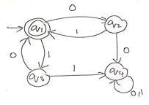
- Consider the following grammar S->aSc|T|U|e
T-> bTc|e U->aUb|
e
A} What is the language defined by the grammar?
B)Give the derivation tree for the word aaabbc
C Grammar is Ambiguous if there exists two distinct derivations for a word. Is the above grammar ambiguous? Justify.

4. I)Show that if L1 and L2 are regular then (L1+l2) also regular Ii)Is the language { a^p| p is prime} regular? Justify RUBRICS FOR CALCULATION
Criteria | Weightag  e | Level 4 –  Exemplary (5  Marks) | Level 3 –  Proficient (4  Marks) | Level 2 –  Developing (2–3  Marks) | Level 1 –  Beginning  (0–1 Mark)
Conceptual Understan din g | 30 | Demonstrates clear and complete understanding of the concept | Good understandin g with minor gaps | Basic understanding with some misconceptions | Poor or incorrect understandin g
Accuracy  of  Answer | 25 | Completely correct answer with no errors | Mostly correct with minor errors | Partially correct with noticeable  errors | Incorrect or irrelevant answer
Application of  Knowledge | 20 | Correctly applies concepts to solve the question/proble m | Applies concepts with minor mistakes | Limited or partially correct application | No or incorrect application
Completene  ss of  Response | 15 | Covers all required parts of the question | Covers most parts with minor omissions | Covers only some parts | Incomplete or missing response
Clarity &  Presentation | 10 | Clear, concise, and well organized answer | Understandab le with minor issues | Somewhat unclear or poorly structured | Difficult to  understand

Answer

1. Accepted Language L={bbbc,; bca,; c,; ca,; caaaaaaa}

where the alphabet is
\Sigma={a,b,c}

Minimized DFA

A minimized DFA merges equivalent states that have identical future behavior.
Since the accepted strings share common prefixes:
- c, ca, and caaaaaaa share the prefix c.
- bbbc shares the prefix bbb.
- bca shares the prefix bc.

Equivalent states are merged, while keeping a single dead state for all invalid inputs.
The minimized DFA therefore contains:
- Start state
- States for the common prefixes (b, bb, bbb, bc, c, ca, ...)
- Accepting states for the required PINs
- One dead (trap) state

Transition Table (Conceptual)

State Purpose
q0 | Start state
q1 | Reads b
q2 | Reads bb
q3 | Reads bbb
q4 | Accepts bbbc

q5 | Reads bc
q6 | Accepts bca
q7 | Accepts c
q8 | Accepts ca
q9–q14 | Read additional as for caaaaaaa
q15 | Accepts caaaaaaa
qd | Dead state
After minimization, equivalent states (if any) are merged and only one dead state is retained.

How State Reduction Improves Performance

Minimizing the DFA provides several benefits:

- Reduces memory usage by storing fewer states.
- Reduces hardware cost by requiring fewer logic gates and flip-flops.
- Increases execution speed because fewer state transitions are processed.
- Consumes less power, making it suitable for embedded and battery-powered devices.
- Simplifies implementation and testing, improving system reliability.

Applications

Minimized DFAs are commonly used in:

- PIN validation in ATM machines
- Embedded security systems
- Digital door locks
- Smart cards
- Authentication modules
- Access control systems

2. Demonstrate how a given finite automaton can be converted into a regular expression.
Write the transitions

From the automaton:

- (q_1->{0} q_2)
- (q_2->{1} q_1)
- (q_1 ->{1} q_3)
- (q_3 ->{0} q_1)
- (q_2 ->{0} q_4)
- (q_3->{1} q_4)
- (q_4 ->{0,1} q_4) where:

● q₁ is the start state ● q₁ is also the final state
- q₄ is the trap state Observe the accepted patterns From (q_1):
- Reading 01 returns to (q_1).
- Reading 10 also returns to (q_1).
- Reading 00 or 11 leads to the trap state (q_4).

Hence, only 01 and 10 can be repeated.
Write the Regular Expression
(01|10)*
The equivalent regular expression is
(01+10)^*
because the automaton repeatedly accepts the patterns 01 and 10, while 00 and 11 move the automaton to the trap state.
Regular Expression:

{(01+10)^*}

- The start state (q_1) is also the accepting state.
- The transitions 01 and 10 return the automaton to the accepting state.
- The transitions 00 and 11 lead to the trap state (q_4), where all further inputs are rejected.
- Therefore, the equivalent regular expression is: 01+10)^*

Question 3

Given Grammar:
STU→aSc∣T∣U∣ε→bTc∣ε→aUb∣ε
A) What is the language defined by the grammar?

Analyze each production separately.

1. Production (T \rightarrow bTc \mid \varepsilon)

Generates:

- ε
- bc
- bbcc ● bbbccc
- ...

Therefore, L(T)={,b^n c^n|0,}

2. Production (U -> aUb| epsilon)
Generates:

- ε
- ab
- aabb
- aaabbb
- ...

Therefore, L(U)={anbn∣n≥0}

3. Production (S ->aSc)

Each application adds

- one a at the beginning
- one c at the end.

B) Derivation Tree for the string aaabbc Leftmost Derivation
S
⇒ aSc
⇒ aUc
⇒ aaUbc
⇒ aaaUbbc
⇒ aaaεbbc
⇒ aaabbc

Derivation Tree

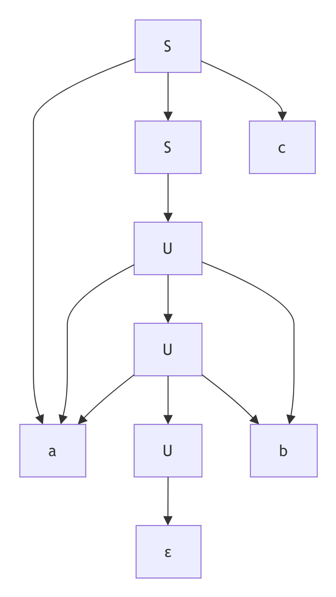

Reading the leaves from left to right gives:

a a a b b c which is aaabbc
C) Is the grammar ambiguous? Justify.

Definition

A grammar is ambiguous if a string has two or more different derivations (or parse trees).

Consider the string ε
It can be derived in three different ways:

S ⇒ ε S ⇒ T ⇒ ε S ⇒ U
⇒ ε
Since the same string ε has more than one valid derivation,The grammar is ambiguous.

